Aerodynamic Analysis of an RC UAV
A CFD Simulation Study in ANSYS Fluent
ANSYS Workbench / Fluent 2020 R2 · Pre-fabrication aerodynamic validation

1. Objective
This report documents the computational fluid dynamics (CFD) analysis carried out on the RC UAV airframe as part of its design process, prior to physical fabrication. Rather than sizing the airframe from empirical rules of thumb alone, the CAD geometry was placed in a virtual wind tunnel and simulated in ANSYS Fluent to study how air actually moves over the fuselage, canopy, and wings at cruise-relevant speeds.
The specific aims of the analysis were to: (1) visualize the pressure and velocity fields around the airframe, (2) identify regions of flow separation, recirculation, or stagnation that could hurt aerodynamic efficiency, (3) cross-check the findings using two different turbulence models, and (4) use these results to guide geometry refinement across successive design iterations before committing to a build.

2. Design Process & Geometry
The airframe was modelled in CAD (SolidWorks, exchanged as STEP files) and went through several design iterations, refining the fuselage/canopy shape and wing planform at each pass. Each iteration was re-imported into ANSYS Workbench and re-analysed, so that CFD results from one revision directly informed the geometry changes made in the next.
For the CFD study, the aircraft geometry was enclosed in a rectangular control volume built in DesignModeler, which acts as the virtual wind tunnel. The enclosure was sized generously around the airframe (100 mm cushion on most faces, 400 mm downstream) so that the tunnel walls would not artificially influence the flow field around the aircraft.
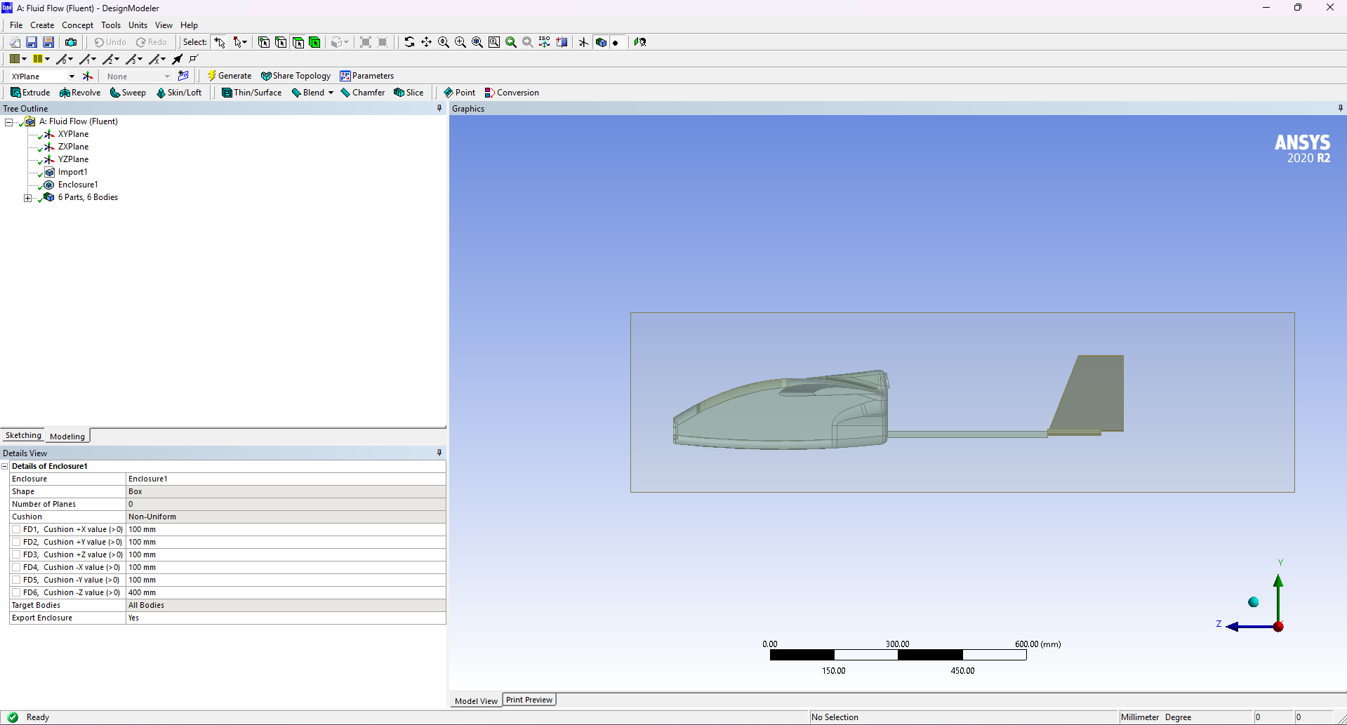
Figure 1 — Aircraft geometry enclosed within the virtual wind-tunnel domain, built in ANSYS DesignModeler. The imported CAD model (6 bodies) sits inside a rectangular fluid enclosure that forms the simulation domain.

3. Computational Domain & Fluent Setup
The enclosure was meshed and exported into Fluent, where the domain faces were assigned as boundary zones — a velocity-inlet upstream of the aircraft, a pressure-outlet downstream, and no-slip walls on the aircraft surface and tunnel walls. The solver was configured as pressure-based and steady-state, using the absolute velocity formulation, which is the standard configuration for low-speed, incompressible external aerodynamics problems like this one.
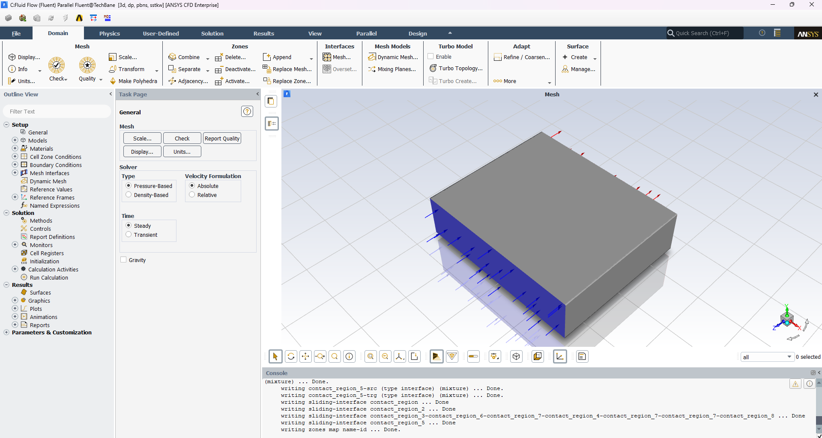
Figure 2 — Fluent domain view showing the meshed control volume, with the velocity-inlet face highlighted in blue. The solver is set to pressure-based, steady-state.

4. Turbulence Modelling
Airflow around the airframe is turbulent at the Reynolds numbers involved, so a RANS (Reynolds-Averaged Navier-Stokes) turbulence model was needed to close the governing equations. Two different models were used across the study, both to resolve near-wall flow accurately and to cross-check that the results were not an artefact of a single model's assumptions:
- Standard k-ε model with Enhanced Wall Treatment — a robust, widely-validated two-equation model, paired with enhanced wall functions so that the near-wall boundary layer is resolved without requiring an extremely fine wall mesh.
- SST k-ω model — used as a cross-check, since it tends to be more accurate for flows with adverse pressure gradients and separation, which was a specific concern around the canopy shoulder on this airframe.
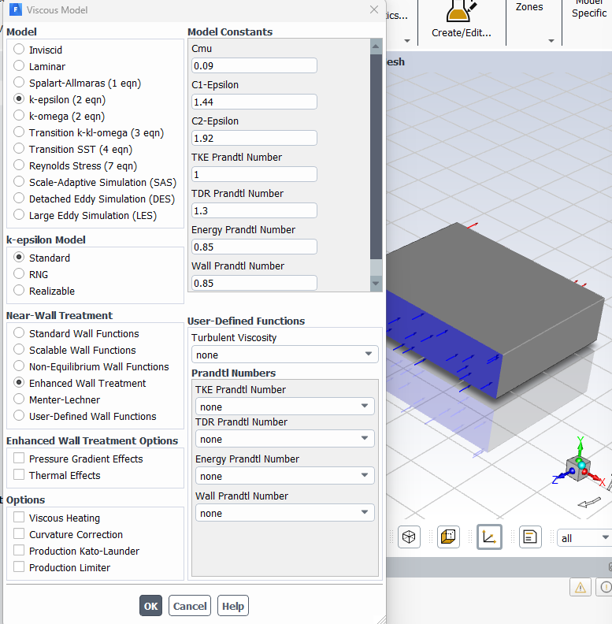
Figure 3 — Standard k-ε turbulence model configuration (Cμ = 0.09, C1-ε = 1.44, C2-ε = 1.92) with Enhanced Wall Treatment for near-wall resolution.
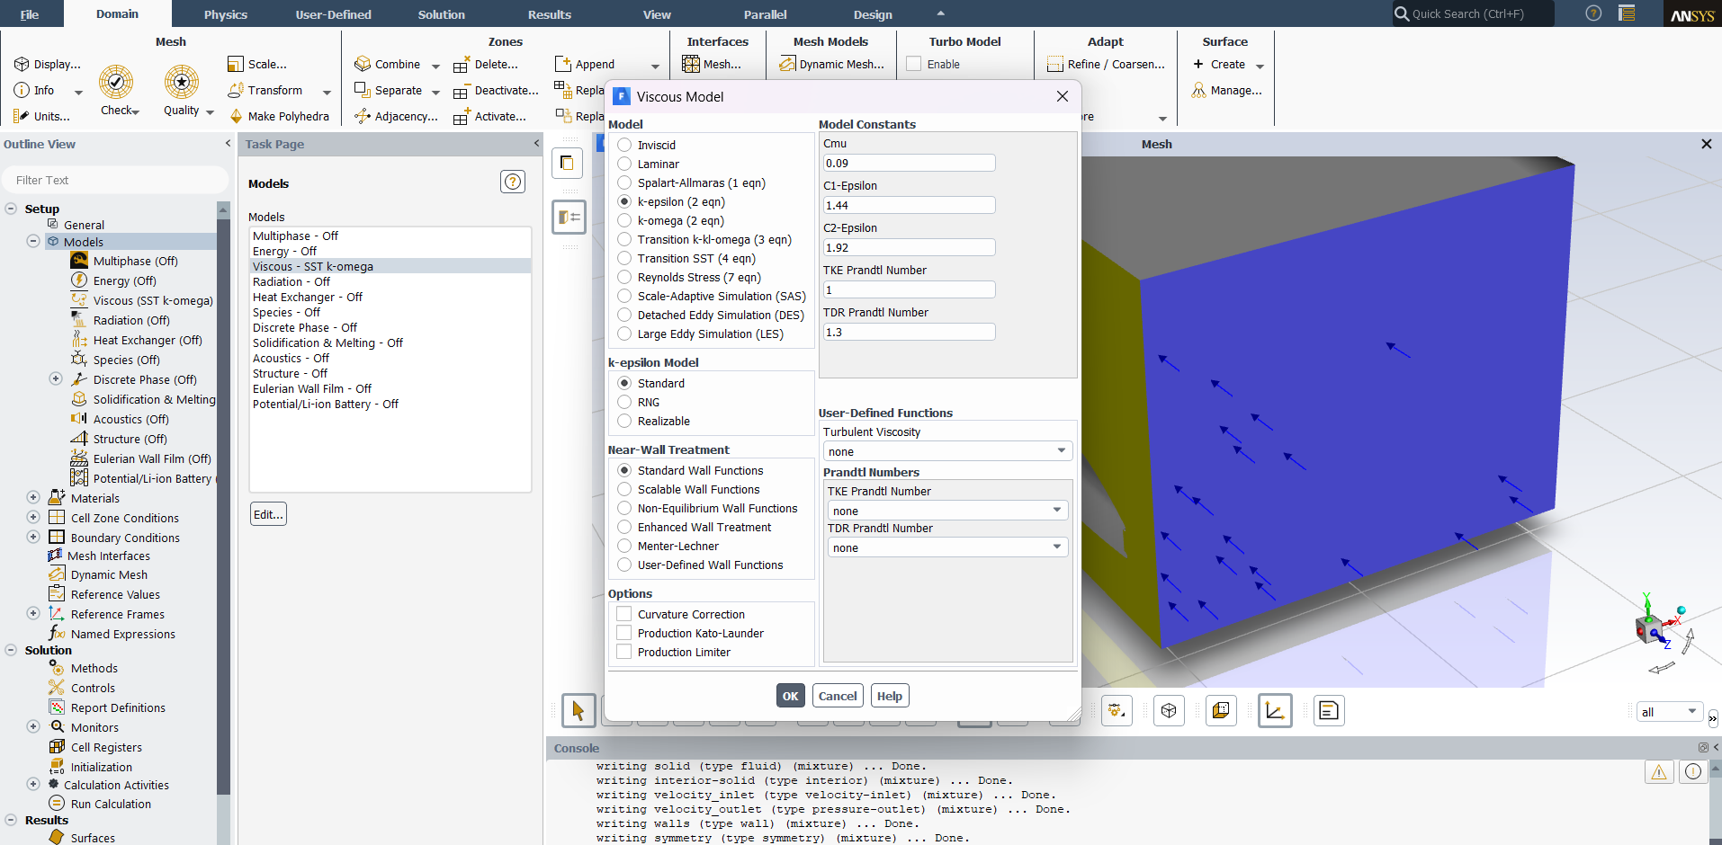
Figure 4 — Viscous model dialog showing the SST k-ω model selected for the comparison study, run with an aluminium solid zone included in the domain.

5. Boundary Conditions
Air was used as the working fluid. The velocity-inlet was swept across two cruise-relevant speeds — 15 m/s and 20 m/s — specified as a velocity magnitude normal to the boundary, with 5% turbulence intensity and a turbulent viscosity ratio of 10, which are standard assumptions for a low-turbulence wind-tunnel-like free stream. The 20 m/s case was additionally run on a symmetry half-model (cutting the domain, and the solve time, in half) with an aluminium solid zone included to represent the airframe structure.
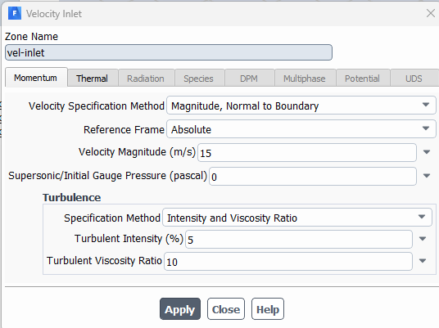
Figure 5 — Velocity-inlet boundary condition for the 15 m/s case: magnitude normal to boundary, 5% turbulence intensity, turbulent viscosity ratio 10.
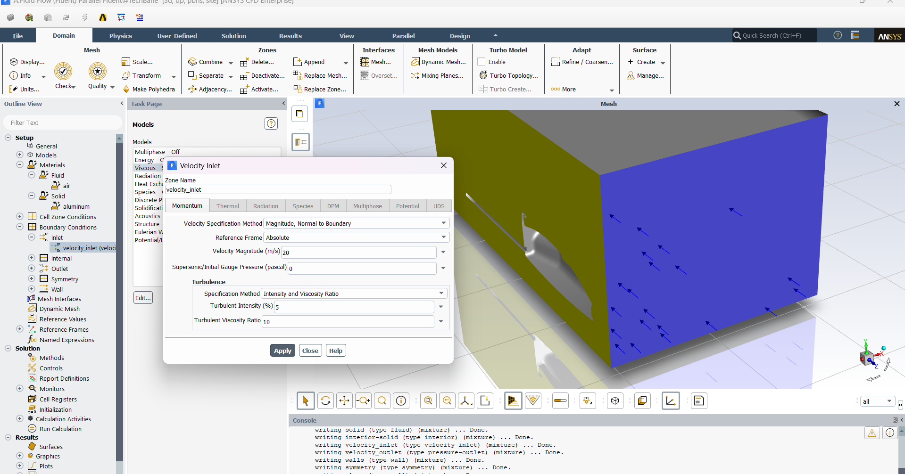
Figure 6 — Velocity-inlet boundary condition for the 20 m/s case, run on a symmetry half-model with an aluminium solid zone included in the domain.

6. Solution Method & Convergence
The solution was initialized (hybrid initialization) and run iteratively until the scaled residuals for continuity, the three velocity components, k, and ε flattened out. In addition to the residuals, dedicated report/monitor files were set up to track the drag force on the airframe and the facet-maximum static pressure and velocity magnitude at every iteration, which gives a second, physically-meaningful convergence check beyond the residuals alone.
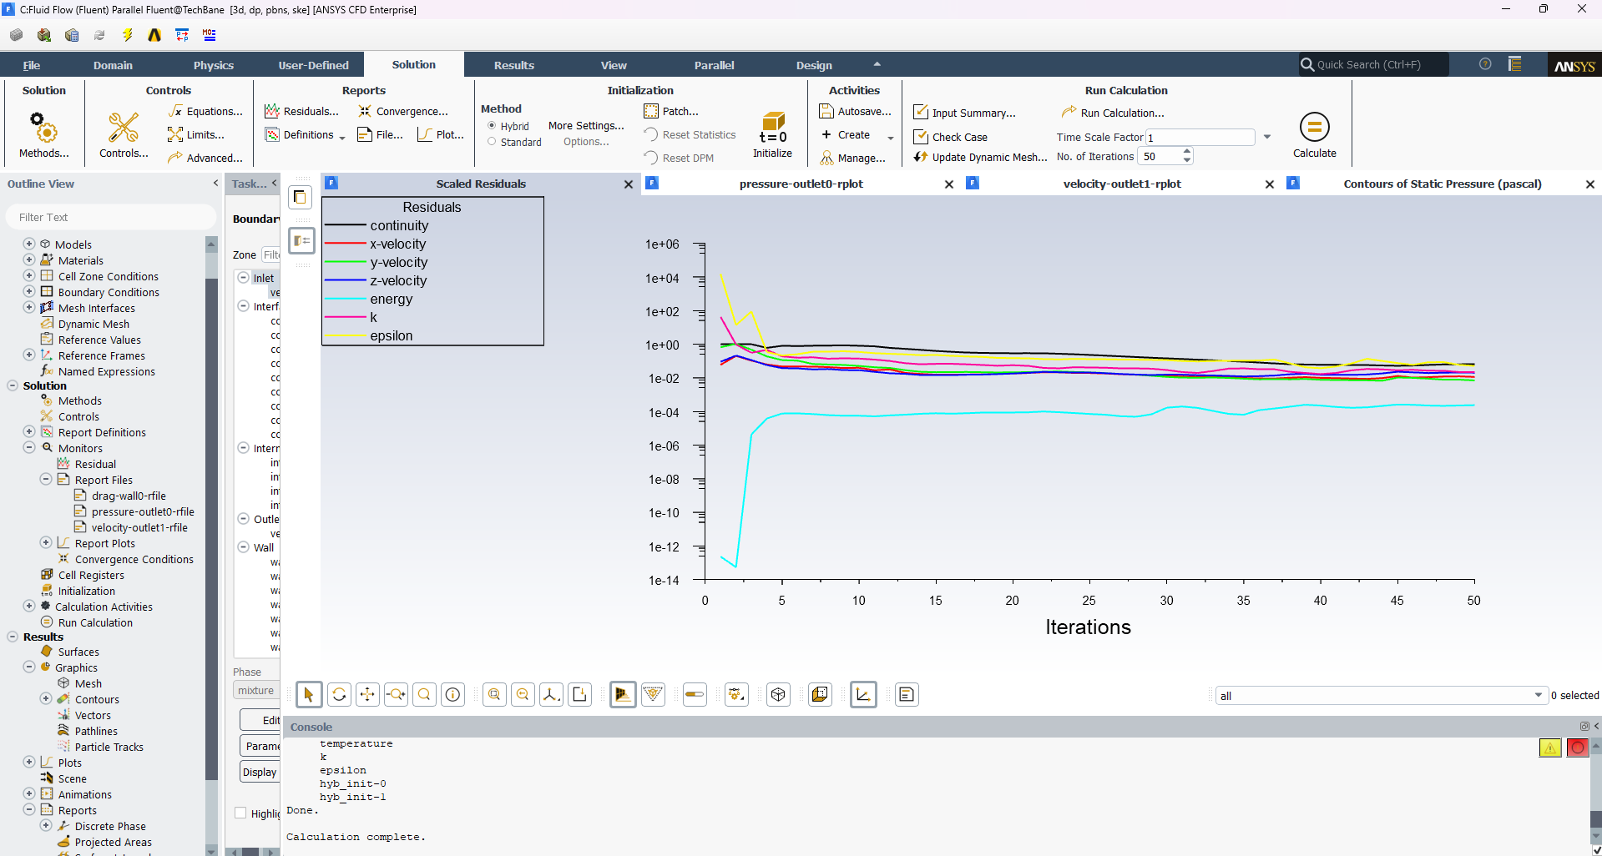
Figure 7 — Scaled residuals (continuity, x/y/z-velocity, energy, k, ε) converging over 50 iterations for the 15 m/s case.
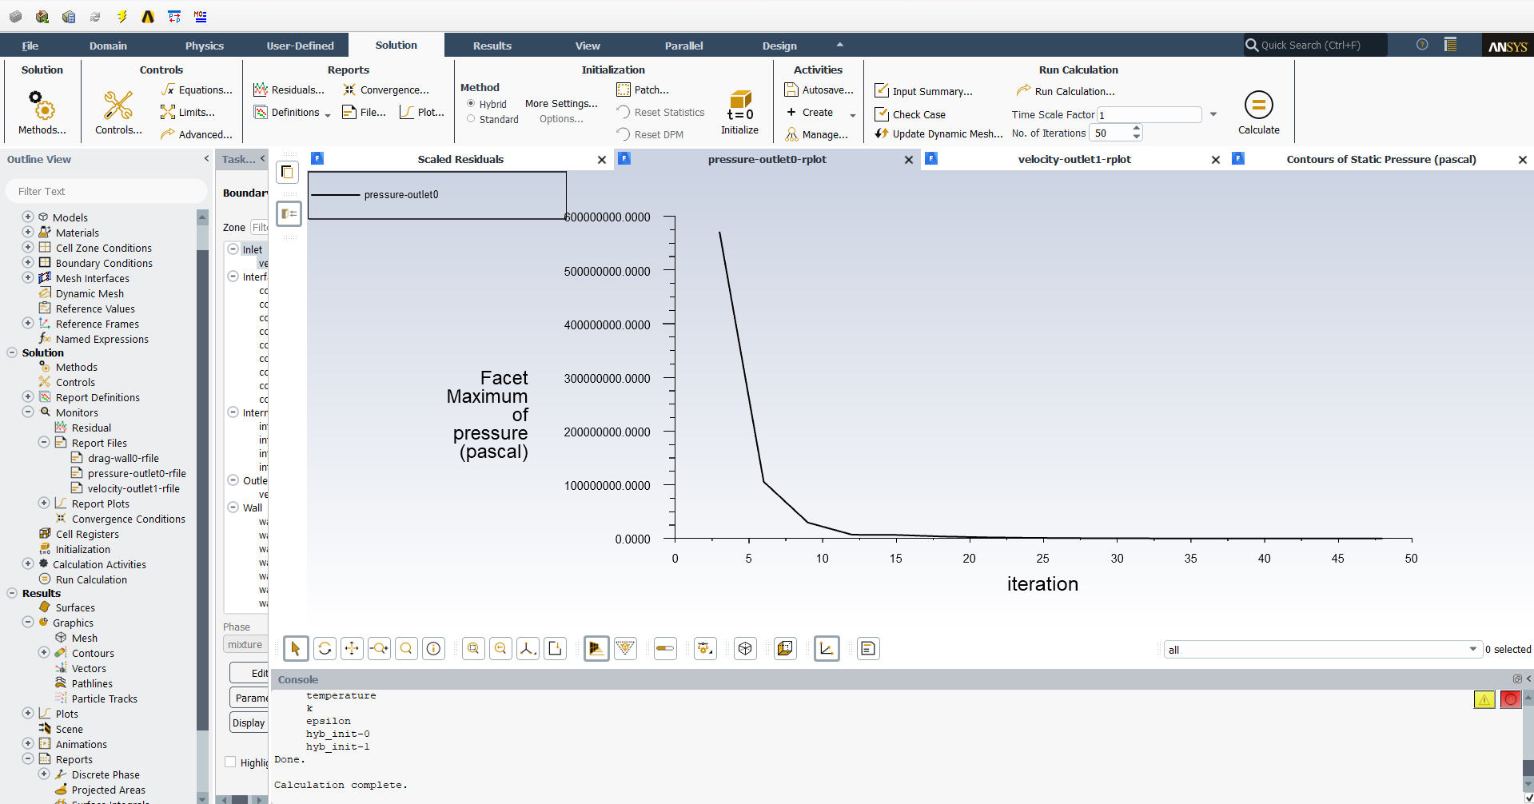
Figure 8 — Facet-maximum static pressure monitor, dropping sharply and settling to a steady value — confirming the pressure field has converged.
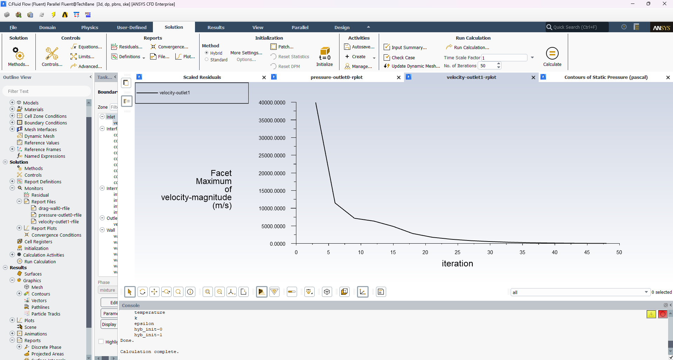
Figure 9 — Facet-maximum velocity-magnitude monitor, showing the same convergence behaviour on the velocity field.
For the 20 m/s symmetry-model case, the solution was advanced using a pseudo-transient time-stepping scheme (automatic time step, conservative length scale) over 100 iterations, which improves robustness for the more constrained half-model mesh.
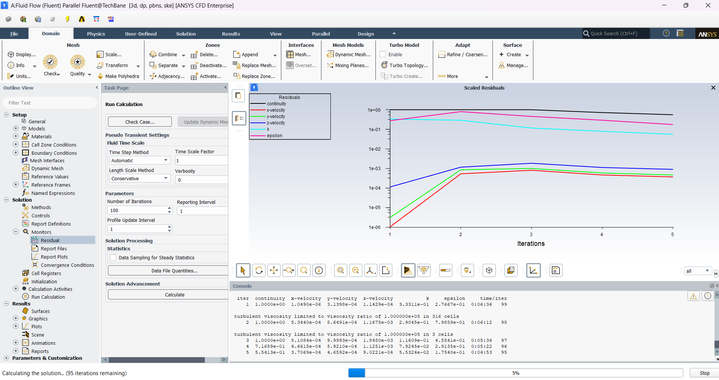
Figure 10 — Pseudo-transient solution settings and early residual trend for the 100-iteration, 20 m/s run.

7. Results — Full-Airframe Flow Field
Once converged, the solutions were post-processed in CFD-Post to visualize the pressure and velocity fields over the aircraft surface and through the domain.

7.1 Static Pressure Distribution
The static pressure contour over the airframe ranged from about −716 Pa to +5.02 kPa (relative to the reference pressure). As expected for this flight regime, pressure builds up at the stagnation regions — the nose and the wing leading edges — where the oncoming flow is brought to rest, while lower pressure develops over the curved upper surfaces where the flow accelerates.
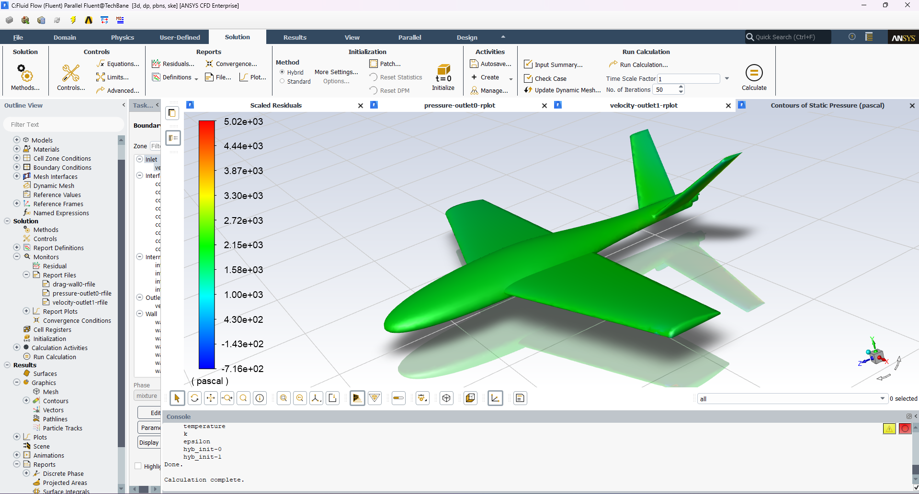
Figure 11 — Static pressure contour over the full airframe (−716 Pa to +5.02 kPa), showing stagnation pressure at the nose and wing leading edges.

7.2 Velocity Magnitude
The velocity magnitude contour over the same surface shows the inverse pattern, as expected from Bernoulli's principle: velocity drops to zero at the stagnation points and rises to roughly 65 m/s over regions of the airframe with the tightest curvature, where the flow has to accelerate the most to get around the surface.
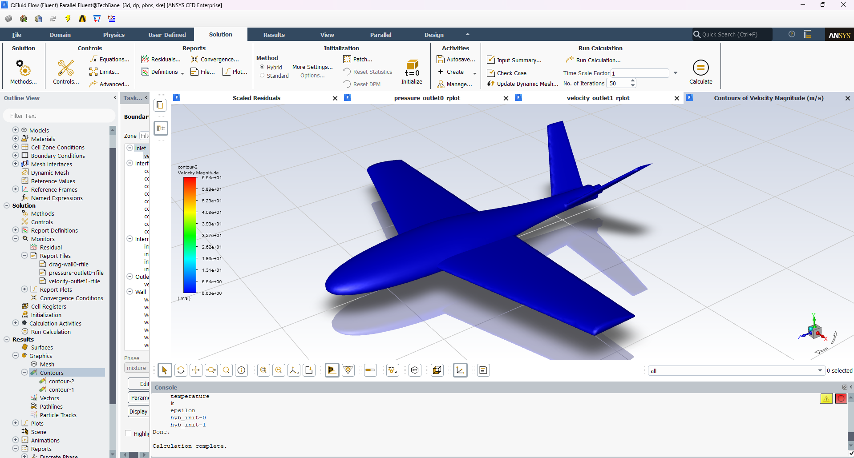
Figure 12 — Velocity-magnitude contour over the full airframe, peaking at approximately 65 m/s over regions of high surface curvature.

8. Results — Flow Field Within the Wind-Tunnel Domain
Looking at the velocity field on a mid-plane slice through the full domain (rather than just the aircraft surface) shows how the wake develops downstream of the airframe, and confirms that the enclosure was sized large enough that the outer boundaries aren't interfering with the wake.
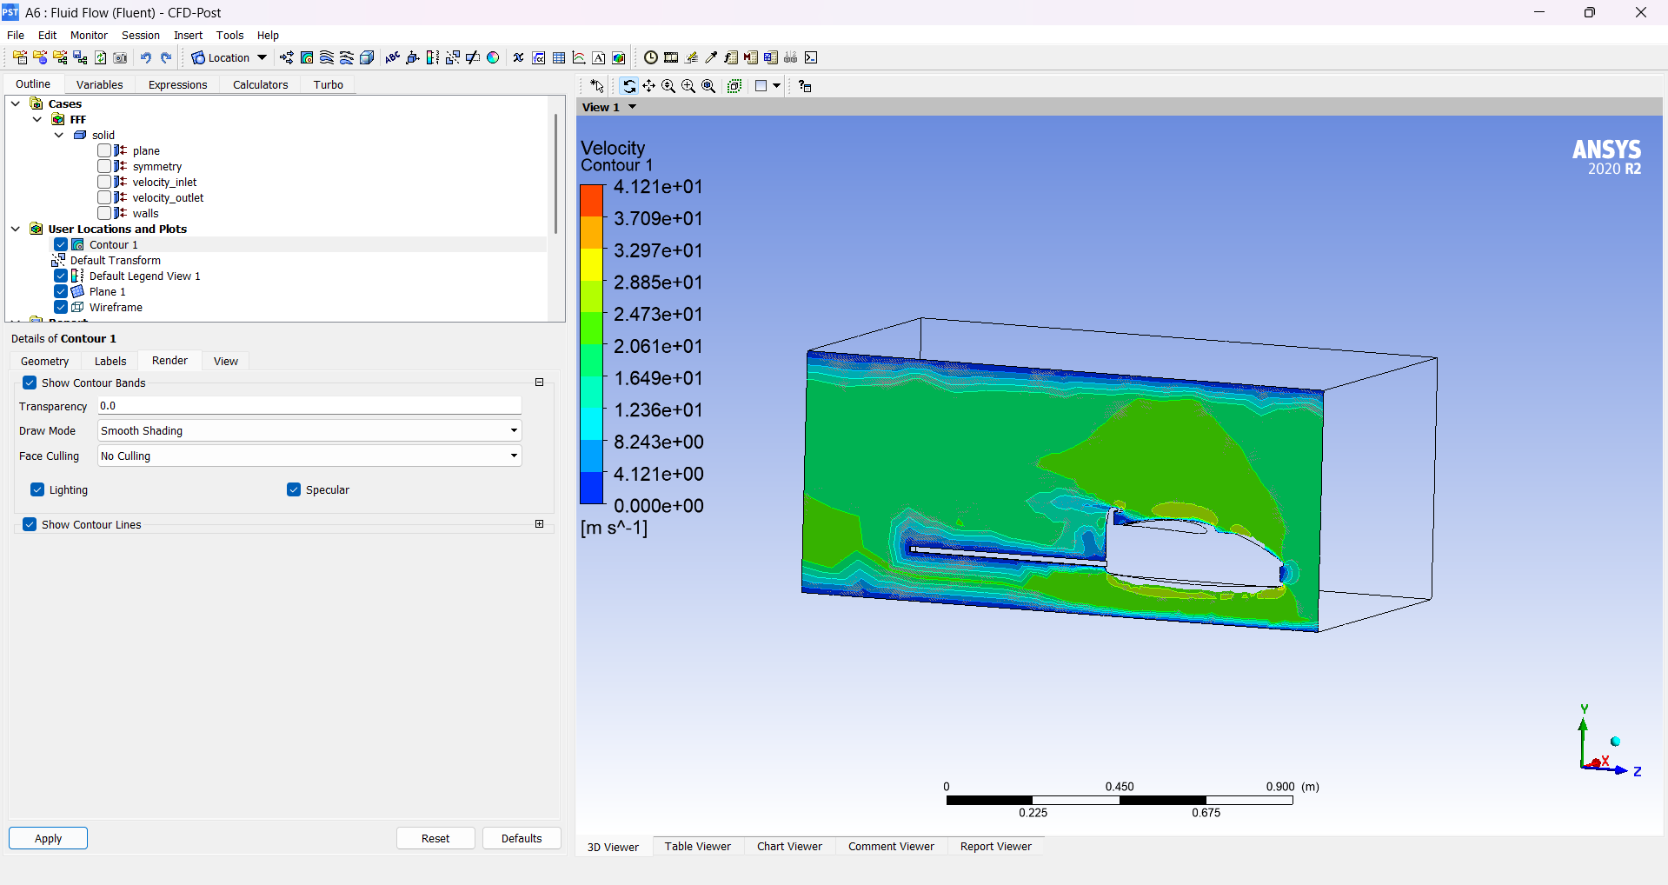
Figure 13 — Velocity contour on a mid-plane slice through the entire wind-tunnel domain, showing the wake forming downstream of the aircraft.

9. Results — Canopy & Nose Region Detail
The canopy-to-fuselage junction was the area of greatest aerodynamic concern in the design, so it was examined in close-up. A zoomed view directly at the nose tip confirms textbook stagnation-point behaviour — velocity falls essentially to zero exactly at the tip, with a thin, well-behaved boundary layer developing along the canopy surface just downstream of it.
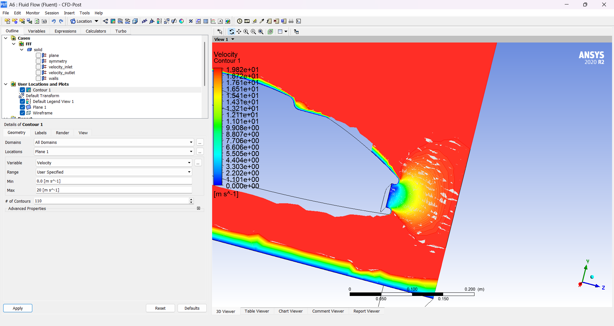
Figure 14 — Close-up of the nose tip: velocity falls to zero at the stagnation point, with the boundary layer building up along the canopy surface immediately downstream.
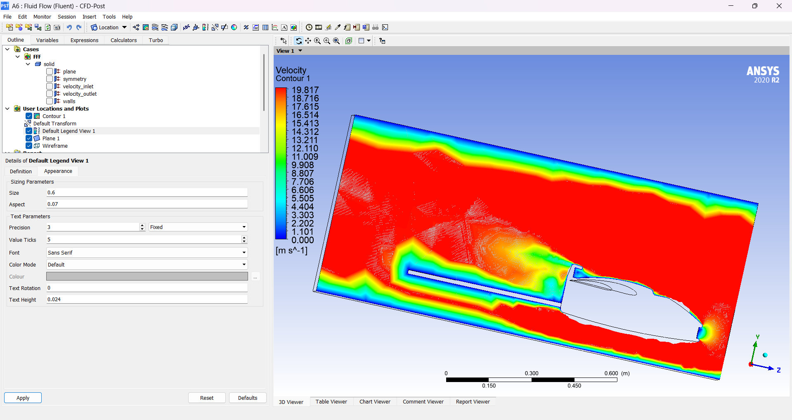
Figure 15 — Velocity contour across the canopy region on a fixed 0–20 m/s scale, showing the thin boundary layer hugging the canopy surface.
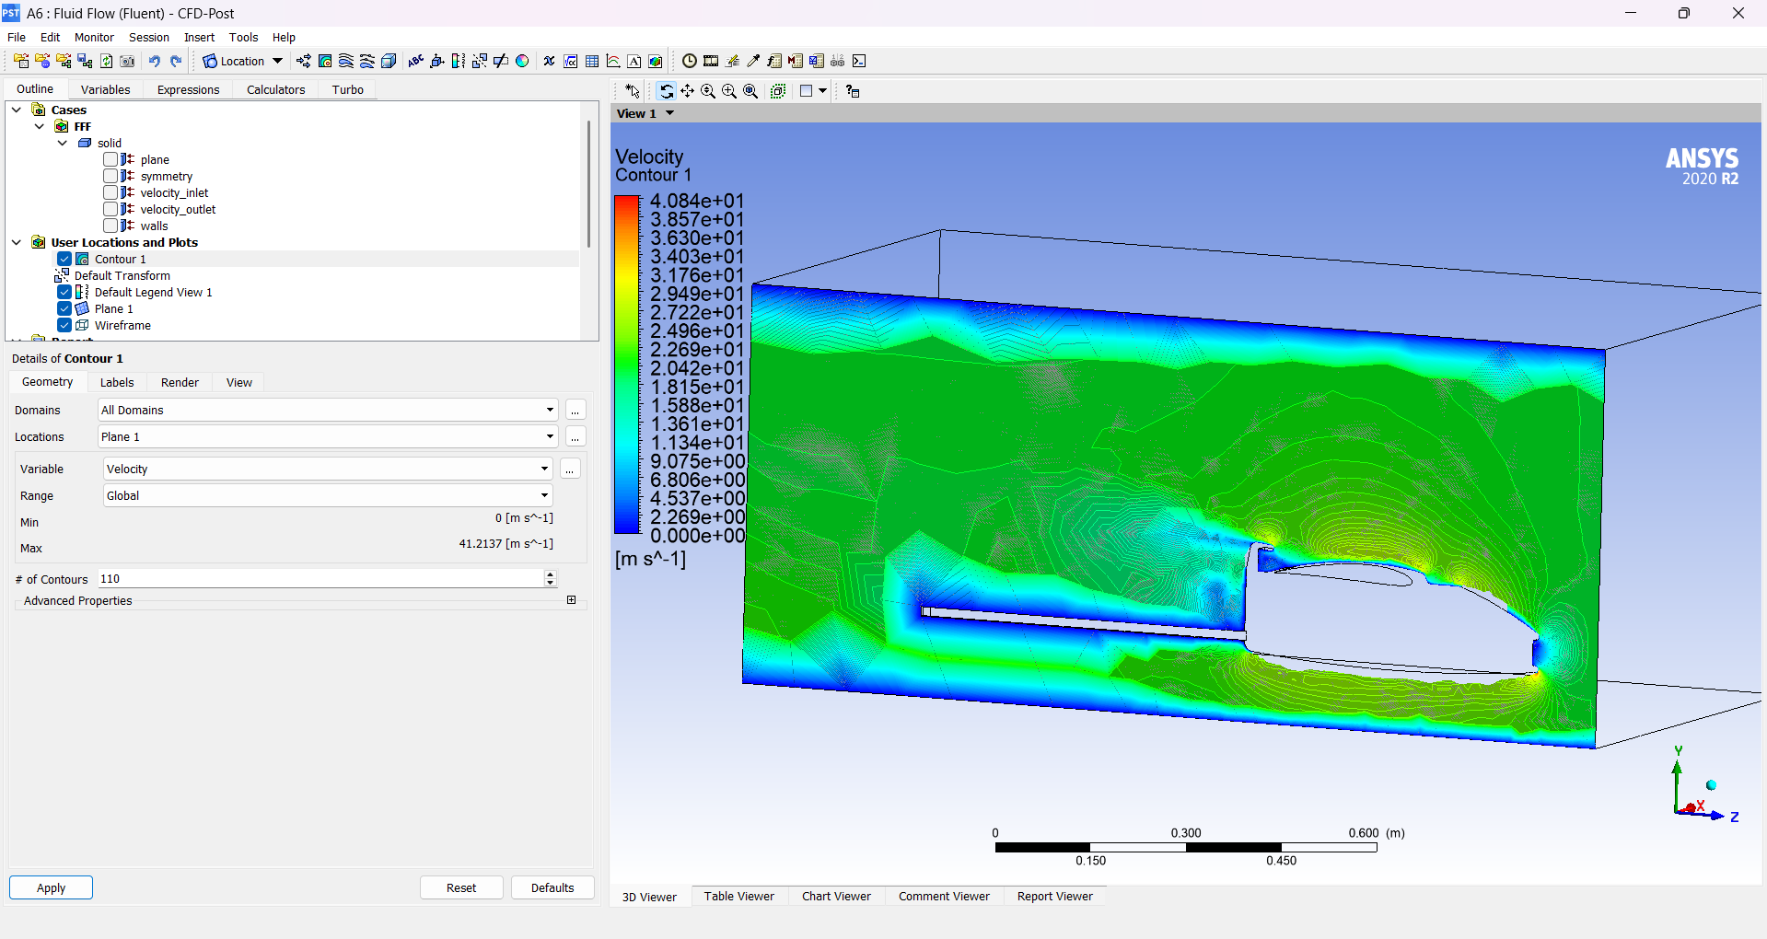
Figure 16 — The same canopy cross-section on an auto-scaled range (up to ~41 m/s), highlighting the local flow acceleration around the canopy shoulder.

10. Vector & Streamline Analysis
Velocity vectors plotted on the canopy cross-section reveal a small recirculation region just aft of the canopy's highest point — a pocket where the flow briefly reverses direction rather than staying attached to the surface. This is the classic signature of adverse-pressure-gradient separation, and it is the single most useful finding from the whole study: it pinpoints exactly where the canopy-to-fuselage fairing needed the most attention in the next design revision.
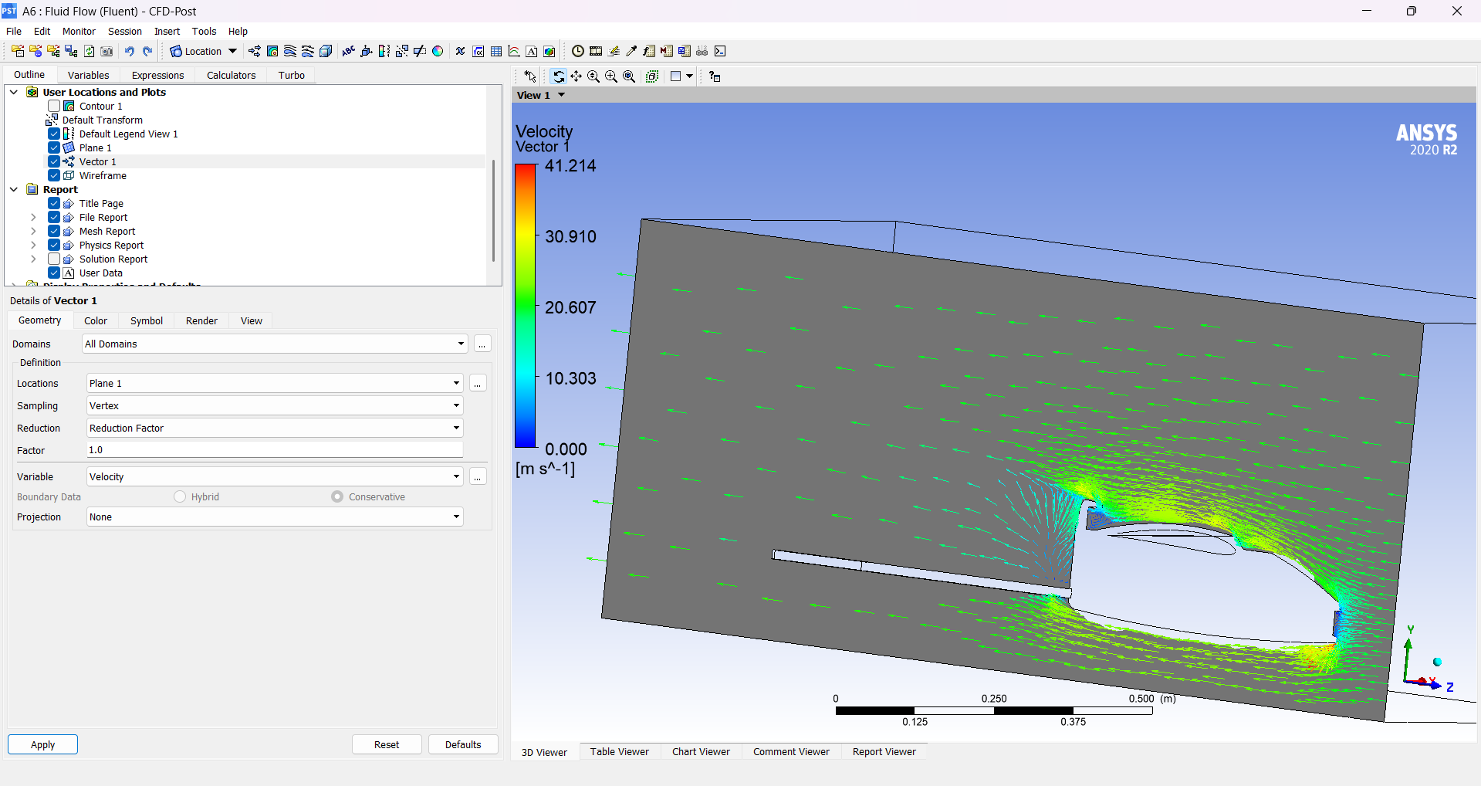
Figure 17 — Velocity vector field on the canopy cross-section. The vectors just aft of the canopy peak show a small recirculation pocket rather than smoothly attached flow.
Streamlines seeded from the inlet and traced through the whole domain confirm the overall flow pattern is well-behaved everywhere except in that same canopy-shoulder region, where the traces bunch and curl rather than running parallel — visually confirming the separation flagged by the vector plot.
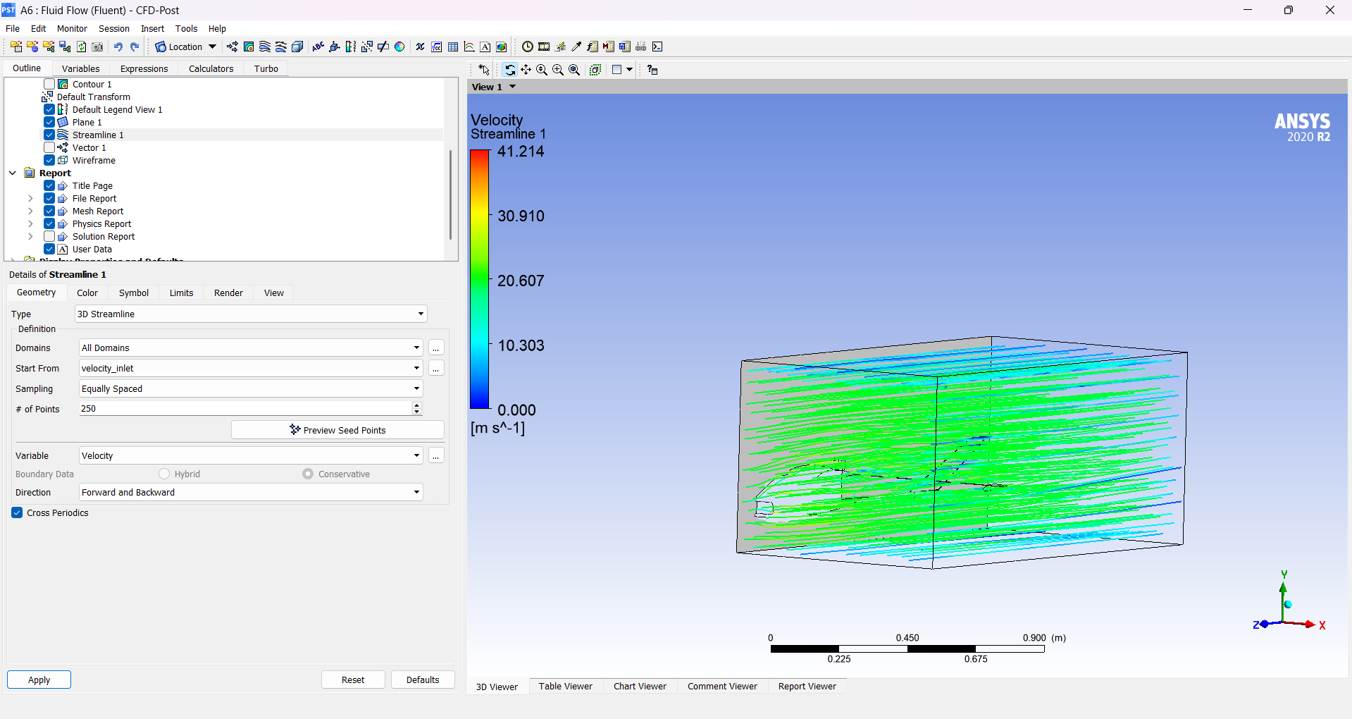
Figure 18 — 3D streamlines (250 seed points) traced from the velocity inlet through the full wind-tunnel domain.
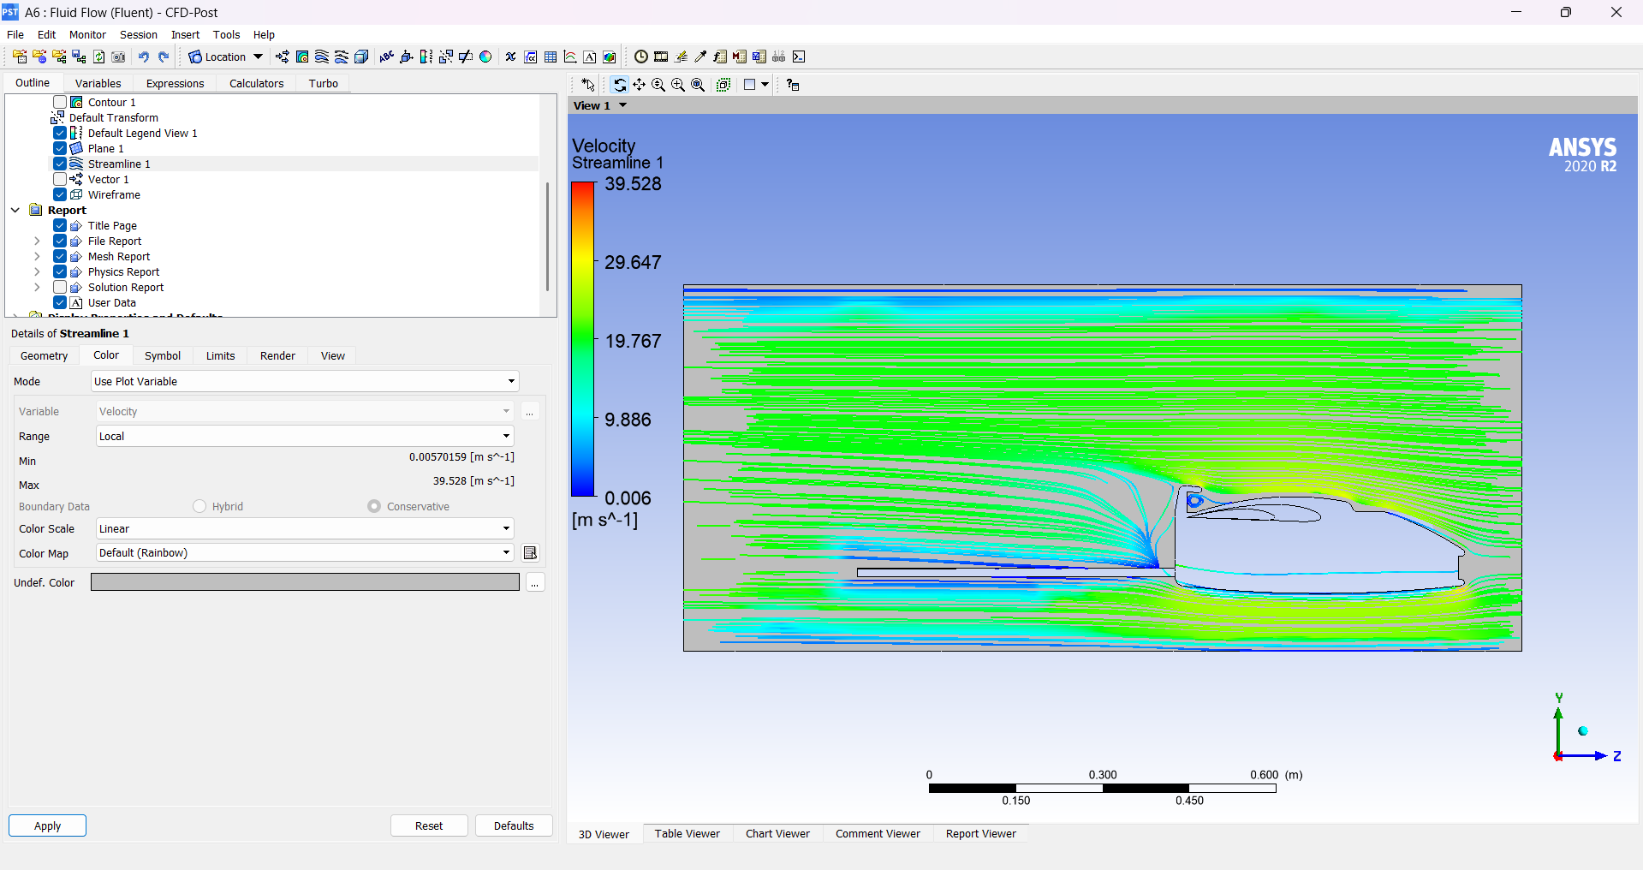
Figure 19 — Streamlines on the canopy cross-section, colour-mapped by velocity. The curling pattern just aft of the canopy peak visually confirms the separation identified in the vector plot.

11. Discussion
The k-ε and SST k-ω runs produced consistent overall flow patterns — stagnation at the nose and leading edges, accelerated flow over the curved upper surfaces, and a developing wake downstream — which gives confidence that the results reflect the actual aerodynamics of the shape rather than an artefact of a particular turbulence model.
The one consistent problem area across every view of the results is the canopy-to-fuselage junction: the pressure, vector, and streamline plots all agree that flow separates just aft of the canopy's highest point, generating a small recirculation pocket. This kind of local separation increases pressure drag and was flagged as the priority for the fairing/fillet geometry at the canopy root in the next design iteration, ahead of building the airframe.

12. Conclusion
CFD analysis in ANSYS Fluent was used to validate the aerodynamic behaviour of the RC UAV design before fabrication, sweeping two velocity-inlet conditions (15 m/s and 20 m/s) and cross-checking the results between the standard k-ε and SST k-ω turbulence models. The pressure and velocity fields matched expected aerodynamic behaviour overall, and the analysis successfully identified a specific, actionable issue — local flow separation at the canopy-fuselage junction — that fed directly back into the airframe's design iterations. This simulation-first approach meant the design was aerodynamically vetted before any material was cut.

Appendix — Simulation Parameter Summary
Parameter | Value
Solver | ANSYS Fluent 2020 R2, pressure-based, steady (pseudo-transient for the 20 m/s case)
Working fluid | Air
Turbulence models | Standard k-ε (Enhanced Wall Treatment); SST k-ω (cross-check)
Inlet condition | Velocity-inlet, magnitude normal to boundary — 15 m/s and 20 m/s cases
Turbulence specification | Intensity & viscosity ratio — 5% intensity, viscosity ratio 10
Outlet condition | Pressure-outlet
Other boundaries | No-slip walls on airframe/tunnel; symmetry plane used for the 20 m/s half-model
Domain | Rectangular enclosure built in DesignModeler around the imported CAD geometry
Convergence monitoring | Scaled residuals + dedicated report files for drag, facet-max pressure, facet-max velocity
Post-processing | ANSYS CFD-Post — pressure/velocity contours, vector fields, 3D streamlines

